Amsterdam Beer Tour 30th June 2006

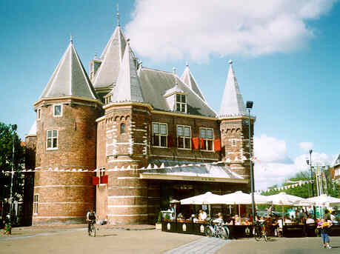

Amsterdam Beer Tour 30th June 2006

11:00 meet in Zwart

11:30 De Beiaard:

12:00 Heineken experience

14:00 Utrechtsestraat:
- Onder de Ooievaar
- Oosterling

16:00 Het Ij brewery tour

17:30 Groene Olifant

18:30 Hesp

19:30 Gollem (the one in de Pijp)

21:00 De Bekeerde Suster

11:00 - Café De Zwart
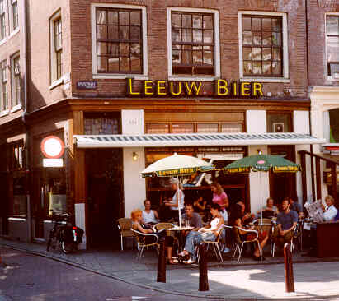
Spuistraat 334,
1012 VX Amsterdam.
Tel. 020-624 6511

I've always liked Café De Zwart. No idea why. I suppose its down-to-earth 1930's style - strangely rare in Amsterdam bars - strikes a chord somewhere deep in my psyche. Either that, or the handy location. Or the fact it's one of Leeuw's scarce city-centre outlets.

If you look very closely, above the doorway you can just make out the leaded glass light above it. You don't get the vibrant red star from this side, obviously. Inside, it's the one stand-out decorative feature.(Since I've been spending more time at home with my family I've gained the opportunity of watching more daytime television than is healthy. So you know where I've picked up terms like "decorative feature".) I've always been a sucker for red stars. What more beautiful sight was there, when searching for a pub, than a red Shippos star twinkling in the distance?

Though Zwart is no larger than your average Amsterdam pub, the corner spot and large windows along two sides make it appear so. Judging by the state of my clothes after one beer, they must redecorate regularly to keep the walls such a light shade.

After years of occasionally making use of Zwart's facilities, I discovered that it has a reputation as a meeting point for intellectuals. I can't say that I had ever noticed. The barman has a good moustache, though.

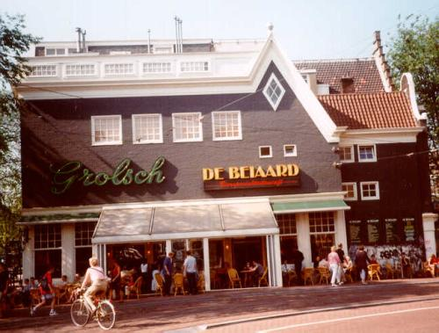
11:30 - De Beiaard
Spui 30,
1012 XA Amsterdam.
Tel. 020-622 5110
http://www.beiaardgroep.nl/amsterdam/

This bar has a very prominent location where Spui meets Singel and the trams make a big left-hand turn on their way up to the Leidseplein. The long frontage and enclosed terrace on the roadside give a somewhat false impression as to its size, as this is a typical long, thin Amsterdam house, and what you're seeing here is its side.

Once inside, it's surprisingly narrow, with a small seating area on the Spui side and up a few steps the bar itself at the canal end of the building. It's all decorated in the sort of trashy American neon signs and assorted advertising tack that people seem to think looks modern and trendy. It's like being caught in some weird TV show set that's trying to combine Al's diner and the bar in Cheers. Try sitting in the terrace - there's no decoration in there and you have a pleasant view of the 17th century church opposite.

The beer selection isn't bad, though the high ratio of draught to bottled beers is a little odd. Whether the turnover is high enough to keep all of these in good condition is the question.

12:00 - Heineken experience
Gerardus Adriaan Heineken entered brewing with the purchase of "De Hooybergh" (Haystack) in 1864. It had been founded in 1592 and had for a while in the 18th century been the largest brewery in Amsterdam. When Heineken came in with an offer, its trade had collapsed and it was losing money.

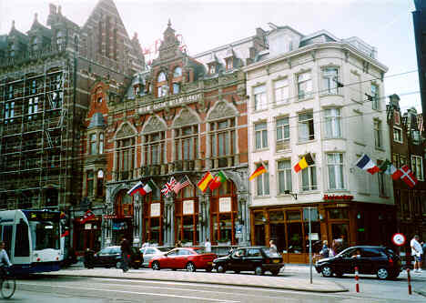
The city centre location on the Nieuwezijds Voorburgwal (176-180 where the "Die Port van Cleve" hotel now stands – it was the same width as the four large windows in the red brick building pictured above) became problematic when in 1865 the coucil decided to fill in the canal in font of the brewery. Forced to move, G.A. Heineken opted for a green-field on Stadhouderskade, on the far side of Singelgracht. Construction of the new brewery started in 1867. They weren't messing about as the first barrels were ready for delivery in January 1868.

Heineken continued to add around the original core until 1970. As lorries got bigger, they had more and more trouble accessing the brewery. I can sort of see why Heineekn got fed up with trying to run a mega-brewery crammed right up against the tennements of De Pijp.

Over the years, a dynasty of Heineken's stuck on new bits. In a pretty haphazard way, judging by the jumble of scale and styles. Aesthetics doesn't appear to have played much of a role in their plans. All that remains today is an over-hasty extension from the 1he 1880's except with the prime spot on the corner of Ferdinand Bolstraat and Stadhouderskade (where in the 1870's they had, bizarrely, added an office considerably lower in height than its earlier neighbours) taken by an elegant 1930's brewhouse. The only bit that was ever that good.

14:00 Utrechtsestraat
Onder de Ooievaar
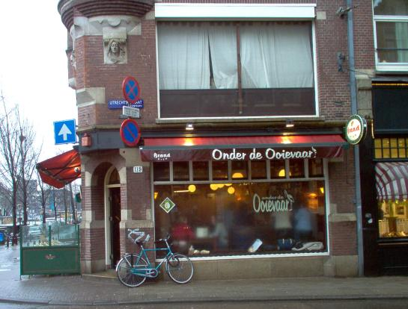
Utrechtsestraat 119,
1017 VL Amsterdam.
Tel: 020 - 624 6836

I didn't time my visit to Onder de Ooievaar very well. They had run out of Paasij the evening before and hadn't got a new supply yet. Oh, alright, I'll just have to make do with Columbus.

Spoilt for choice. Lucky bastards. That's my opinion of those lucky enough to live around the Utrechtsestraat. As if just one cracking pub (Oosterling) wasn't enough for them. OK, Ooievaar is very different in style - light, airy - but still has a relaxed and relaxing atmosphere. A place where you can sit and read the newspaper. Or have a quiet chat.

There is music, but soothingly Cuban and played at a volume that still allows conversation. My god, civilisation isn't quite dead yet.

The big windows on two sides do give a shop-like air to the place. And it's mostly filled with yuppie-ish twenty- and thirtysomethings. But don't they have to hang around somewhere, too? (Don't suggest the bottom of the harbour, please.) I didn't find them too obtrusive.

The small list of bottled beers does include four from Het IJ. So, go on. Drink a real Amsterdam beer in a real Amsterdam pub.

Oosterling
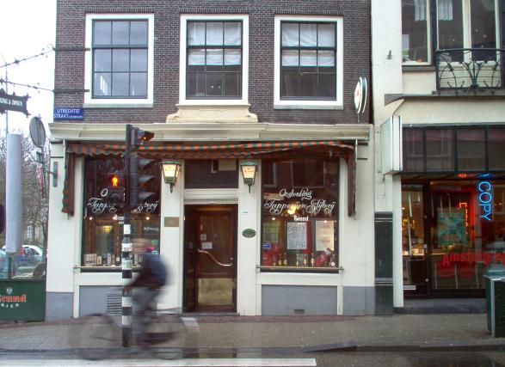
Utrechtsestraat 140,
1017 VT Amsterdam.
Tel: 020 - 623 4140

It may be stuck right at the far end of Utrechtsestraat, but Oosterling is well worth the trek. Those who can be bothered will be rewarded with an unspoilt locals' pub.

Oosterling is one of a very rare breed - a bar that still has an off-licence. Or a Slijterij-Tapperij as they call them in Dutch. The authorities took against the concept some time ago and stopped issuing new licences. The numbers are wittling away as landlords retire. Amsterdam is now down to a mere handful of such establishments.

A low bar occupies the whole of one wall. It's quite nicely carved, though not too extravagantly. At the door end it serves as the counter of the small off-licence section. This consists, so it seems, entirely of spirits. So perhaps I can understand the council's lack of enthusiasm.

Are you a copper, brass or zinc person? Well, Oosterling goes for the most obscure - and it my opinion the most decorative of the options: copper. Very cosy and welcoming. But enough of how they look - I bet you're wondering what comes out of them? With four Brand beers, I think we can assume that there's some sort of tie thing going on. I had heard that Brand had drastically pared back its range, so it was quite a shock to see Impeartor, one of the supposed victims. In addition there's De Koninck and a "beer of the month" - Westmalle Dubbel when I was there.

Though it's a decent-sized pub, there aren't a great number of tables. Perhaps that's so the delightful mosaic stars are more visible. I've always been a sucker for stars, no matter how many points they have.

As you will be able to see to the right, if you pick a table at the window you'll be sitting under an impressive row of old spirit barrels. Rather you than me. I've always been of a nervous disposition.

I'm sure that I've told you this before, but remote locations do have their benefits. Look, I've nothing against tourists, but it is occasionally pleasant to sit in a genuine Amsterdam atmosphere. Oosterling certainly has that. And no music.

Listening to the locals chat about the monarchy ("an anachronism" was the conclusion) and the progress of their redecorating (still not finished) while the rain steamed up the windows was a soothing start to my Saturday. I'm sure it works just as well on any other day of the week.

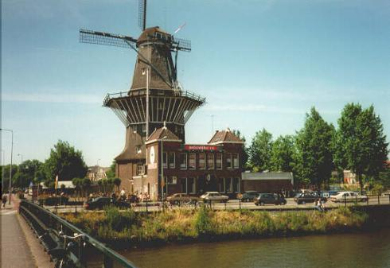
16:00 - Het Ij brewery tour
Funenkade 7,
1018 AL Amsterdam.
Tel. 020-622 8325

The wonderfully simple brewery tap of the Ij brewery, in a picturesque windmill on a canalside, is most definitely worth the trip out of the city centre. The slightly inconvenient location helps prevent it being overrun with tourists and, no doubt, keep the prices down.

It's very basic inside, with an incredible collection of beer bottles plus a couple of old signs from the buildings previous life (as a public baths) forming about the only decoration.

Through a set of double doors you can see through into the brewery itself, but as this is a small brewery with a tasting room attached rather than a pub brewery, the equipment is purely functional rather than having a dual decorative purpose.

In the Summer, there's a small garden area outside. But be warned that the number of seats is quite small, so if you want to soak up some sun with your alcohol, get there very early. At the weekend in can get very full very soon after opening time, with a fairly diverse crowd.

The draught beer range varies slightly with the season - in Easter there's Paasij, in Autumn a Bokbier - but you'll always find four or five on tap. Given the limited availability of their beers on draught elsewhere (they can't supply demand), this is your best bet for finding Ij products. Oh, yes, it's also amazingly cheap, with the strongest beers only costing €2.50 for 30cl.

Note that no alcohol is sold other than their own products, except for wine.

17:30 - Groene Olifant
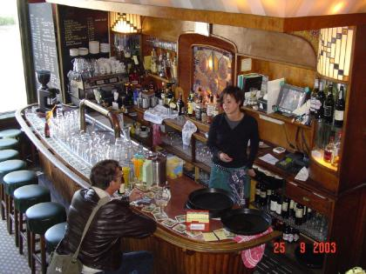
Sarphatistraat 510,
1018 AV Amsterdam.
Tel. 020 - 620 4904
Fax: 020 - 320 7227
Email: info@degroeneolifant.demon.nl
Https://www.degroeneolifant.nl

Here's a place that I never did spot from a tram. Just when I was feeling pleased with myself for having found it (OK, Mikey led me there, but it felt like a voyage of discovery), I noticed that everyone and their aunty suggests it as a destination when you get kicked out of Het Ij. Personally, I'm impressed with anyone who's up for more beer after a visit to the windmill. I think I'm doing well if I can find the bus stop.

So for the two people out there who don't already know, Groene Olifant (Green Elephant) is tucked away in a backwater between Singelgracht and Artis. We're in familiar brown café territory, which by now needs no further definition from me. The highlight is a graceful carved wood and leaded glass bar back (see photo).

No great choice of beers, but it does make a change to have Leeuw rather than Dommelsch, Heinken or Amstel. Not that I think the Leeuw beers are any better, they just add variety.

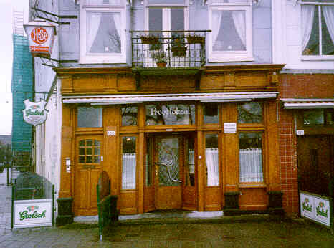
18:30 - Hesp
Weesperzijde 130-131,
1091 ER Amsterdam.
Tel. 020-665 1202
Fax: 020-463 0085
Email: hesp@xs4all.nl
Homepage: http://www.cafehesp.nl/

I'll put this at the start so you don't miss it. Hesp is worth the trek.

What is Hesp? Hesp is a dark brown café in a very odd corner of Amsterdam, sandwiched between the river and the railway line, just about the length of a particularly long train of irate commuters away from Amstel Station. As the colourful leaded glass front door says, it's been going since 1890. (I wonder for how many people this statement of chronological certitude has been the last sure memory of a memorable night?)

Let's be honest: this is a part of Amsterdam I hadn't yet got around to visiting, before seeking out Hesp. Now, having house-hunted (and searched for afterparties) here, I've seen pretty well every corner of the city, in the course of one fruitless journey or another. My son's determination to travel every tram route from terminus to terminus has also taken me to places you really don't want to go to. And still; the closest I had ever come to Hesp was sitting aboard an ICE to Dusseldorf.. Let's say that it's slightly out of the way for the casual visitor. Unless you happen to fall out of a train.

The main section has two rooms - at the front is the bar counter and a couple of tables (you should be able to see most of that in the photo above . . . or, if you have a microsoft browser, somewhere below . . . perhaps). At the rear are some more bits leaded glass, and very pretty they are, too. You can't knock the Dutch for their commitment to leaded glass in a domestic context. (If anyone, in your presence, ever tries to belittle the commitment of the Dutch to leaded glass in a domestic context, just remember my words.) It has the usual mismatched wooden furniture, bare floorboards and nicotine-dark walls. A collection of beer memorabilia brightens up the place a little. (After a while, it starts getting difficult to come up with anything very new or engaging when writing these descriptions, even when the pub in question is as good as this one. I just can't be arsed to try.) An opening has been knocked through to the house next door, where there is a restaurant kitted out in a similar style. I've not eaten here, so don't ask me about the food. I'm not so affluent that I can dine out in my home town.

The draught beer selection is wide and varied, the German-style wheat beer being a particularly refreshing variation. The bottled beer selection is surprisingly limited, barely equalling the draught. But, look, I'm not going to get through all the draught beers in one session, anyway. Hesp's good points - and there are plenty of those - easily outweigh quibbles about numbers.

Overall, an excellent specialist pub, worth the journey out of the city centre. The easiest way to get there is with a train or metro to Amstel Station, from which it is a 5 minute walk. However, depending on the weather, it can seem so much longer. Try, as I did, to select a very wet and windy day for your first visit. There's a bit of a price to pay in terms of soggy misery, but I guarantee you in return at least one half hour of pure magic.

In the Summer there is outside seating alongside the river. Very pleasant, if the weather's good. But as 2006 hasn´t been so terrifically hot, that isn't likely to be the case for a decade or two.

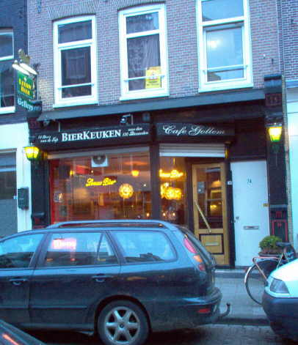
19:30 - Gollem
Daniel Stalpertstraat 74,
1072 XK Amsterdam.
Tel: 0641 - 656238
Http://www.cafegollem.nl/bierkeuken/default.asp

The second Gollem café. It's an event to be celebrated, when a new specialist beer pub opens in Amsterdam. Even more so when if offers beer cuisine in addition to all those pretty bottles. I'm just wondering how I managed to miss it (the opening was November 2004). And it's a stone's throw from the former Heineken brewery.

Compared to the Gollem in the city centre, this one's positively spacious. The pale-coloured walls contribute to the effect of roominess. The usual enamel beer signs are used with positive restraint.

I'm not so sure about the "starburst" lights over the bar counter. They don't really fit with the brown café theme that's going on here.

The beer list is exclusively Belgian, the Ij beers and Pilsner Urquell excluded. Which is a bit disappointing. I almost forgot, they do have La Trappe, presumably to give them the full set of Trappists (yes, Westvletern is on the list). It would have been nice to see a couple more beers from Dutch micros.

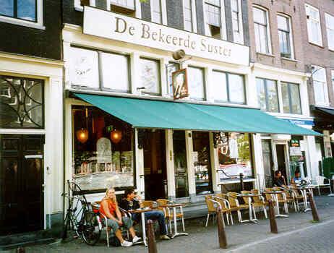
21:00 - De Bekeerde Suster
Kloveniersburgwal 6-8,
1012 CT Amsterdam.
Tel. 020-423 0112
Email: info@beiaardgroep.nl
Http://www.beiaardgroep.nl/brouwerij/

Formerly the brewpub Maximiliaan, which went bankrupt after about 10 years in business. De Bekeerde Suster is now owned and run by De Beiaard Groep, who have another cafe in Amsterdam on the Spui. The beer range has been expanded from the Maximiliaan, when the pub only sold half a dozen or so varieties, all except the pils being brewed on the premises. After a worrying delay, when it operated solely as a specialist beer cafe, the brewery is back in regular operation. (If you want to catch them in the act, their website reveals they usually brew on Wednesday or Thursday.)

De Beiaard had already been getting a couple of house beers contract brewed for their pubs, most notably the witbier Witte Ros and the seasonal Bock Ros. One can assume that the intention is to take the production of these beers in-house. Whether this has occurred yet with the Witte Ros is not clear. Blonde Ros definitely is brewed on the premises, as they say will be the Bock Ros in autumn.

Amsterdam's first (and so far only) brewpub, it opened in 1992. It's situated in a group of historic buildings close to the Waag, a gothic pile in the middle of Nieuwe Markt that was once a gatehouse in the city wall. I had read that the bar area had been altered but, unless senility is closer than I had thought, that's not true. All I could spot in the way of change was an increase in the Grolsch adverts, sorry, memorabilia, which stay just the right side of irritating.

One of the reasons I sometimes tire of visiting new homebrew pubs, is the thought of the hours it might cost finding some new way of combining the words vessel, copper and gleaming without repeating myself. I'm short of time today, so you'll have to use your imagination. It's probably my mind playing tricks on me, but I thought the brewing kit was looking a bit sheepish, there in the corner. Had I been lead in blindfold (which, I admit, was unlikely), I might have feared that my eyesight was slipping away. Hopefully, someone had just knocked against the dimmer. They must have a dimmer . . . You must be able to get it brighter than this.

The custom of using the bits that brew the beer as decorative features, doesn't seem to mean that we ever get to see it used. In Maximiliaan I had seen real live brewing not once, but several times. Seeing all that gear lying around unused was saddening. I'm pleased it's been resuscitated.

